Question 1 (AA1, AA2):

a. Select 2 game engines and list 4 reasons why one particular game engine was selected (giving advantages of the game engine) and why the other was not selected.

Unity and Construct 2

For this particular game, I have chosen the “Unity” game engine. I have chosen this game engine for the following reasons. These reasons will help developing the game.

* Multi-platform
* Library of components
* Easy to script on c#
* Free version not limited

b. Select 2 programming languages (1 mark) used in game development and choose one to support the game engine chosen and list 4 of its features (1.5 marks each) 7 marks

Java and C# The programming language which I have chosen to support the game engine is “Microsoft C#”. This particular programming language will help me creating this game by using these 4 features listed below.

* Standard library
* Boolean conditions
* Object Oriented
* Integration with windows

Question 2 (SE1): 10 marks

Prepare detailed design documents for the game:

1. One Game design document (State Diagram) should contain an overview of the whole game, from the Start Menu till the end showing correctly the interactions between the scenes 5 marks

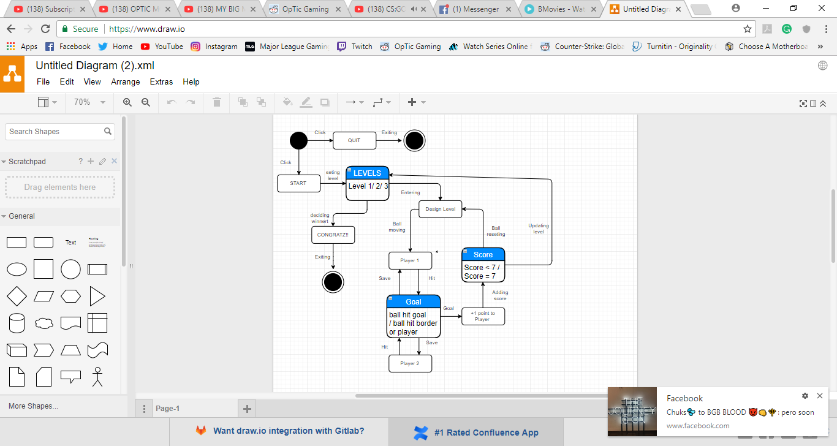

1. The second design document should contain a detailed State Diagram of either Level 2 or Level 3 of the game showing correctly all events and interactions happening in the scene 5 marks

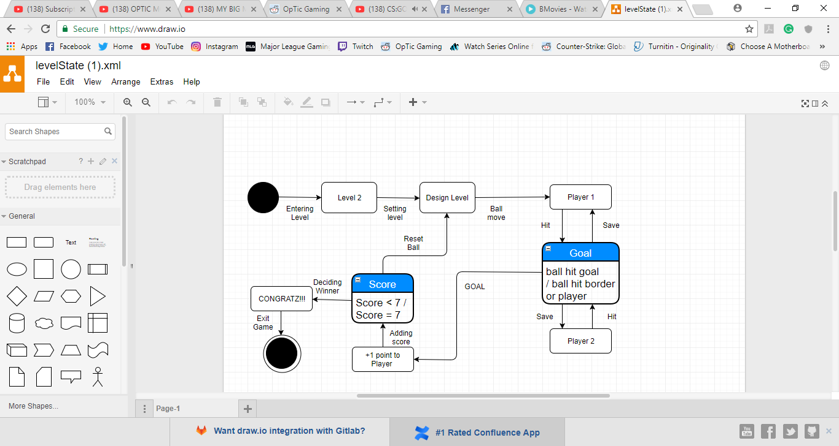

Question 3 (KU 4) *5 marks*

In not less than 100 words, explain why compression is needed when using media assets such as images, videos and audio. Provide examples

Data Compression is needed in media assets because files such as videos, images and audio preoccupy most Data space in the storage space. There are 2 types of file compression lossless and lossy. Lossless can redevelop the whole file exactly and lossy searches the internal code to find pieces which can be deleted this type cannot run on program files only multimedia files. Data Compression refers to the dramatic reduction of file size since they consume more space when compared to written documents and this results into the owners or creators saving more money on storage space and saving time storing. This creates more disk space, faster writing and reading time, faster file transfer. The most used file formats for compression are JPEG, ZIP, GIF.

v